**­­Analysis of Climate Change Indicators – World Bank**

For this analysis, 16 countries in total were filtered out from all continents and regions for even representation. Advanced economies as well as emerging ones have been selected for uniformity of comparison where possible.

Several indicators have been selected relating to the Economics, Energy and Fuel Consumption and land Topography of the countries. The World bank data sets span from years 1960 to 2022, however for multiple metrics and countries, values for the initial years are missing. Appropriate starting years have been selected in such cases.

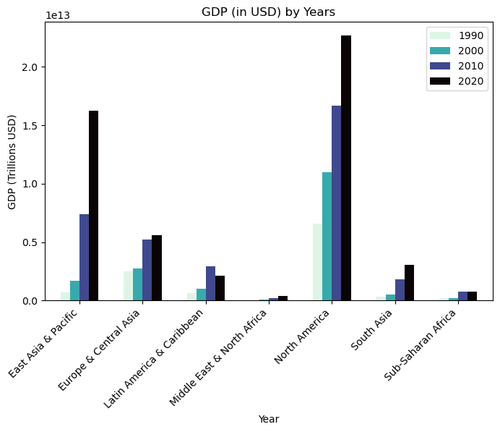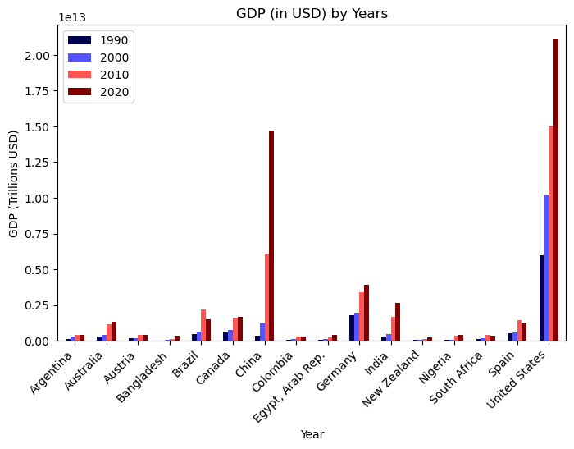

Both graphs above represent GDP growth over a decade, ranging from 1990 to 2020. Of all the regions in the world, North America and East Asia seem to dominate in terms of total GDP. This regional growth is specifically skewed by the United States and China in their respective regions. Both countries have seen exponential growth in their total GDP compared to other countries.

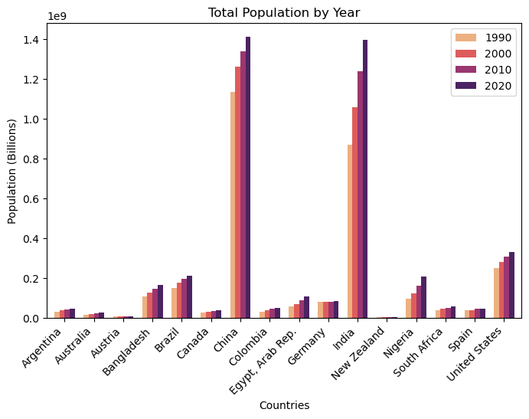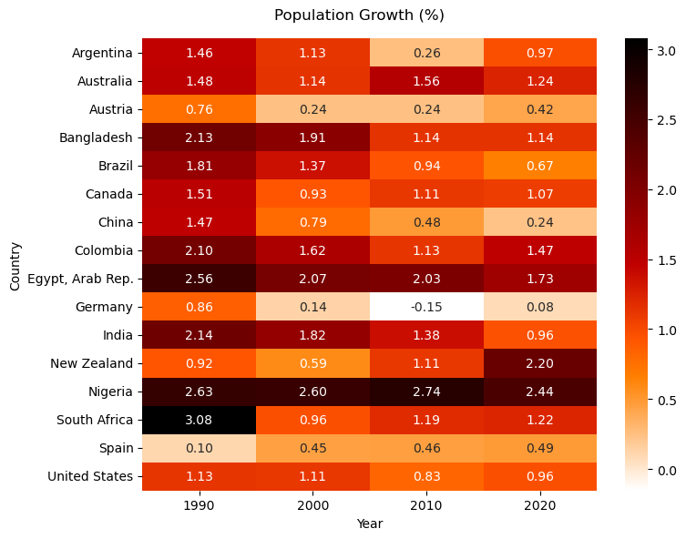

One of the reasons China has enjoyed its economic boom is its population dividend. China and India have the highest populations in the world, both north of a billion people. India is just beginning to utilize its human capital, as signified by start of an exponential GDP spike in the graph above. The heatmap on the right shows that Population growth rates are declining apart from a few countries. However, with improvements in economic growth, Urban populations are on the rise. The heatmaps below show a steady increase in Urban populace for all countries, as well as exponential GDP per capita growth.

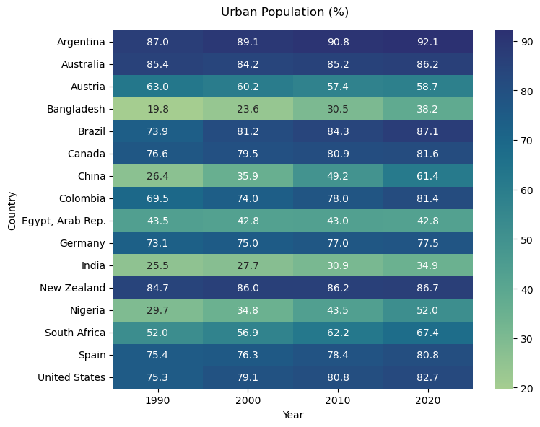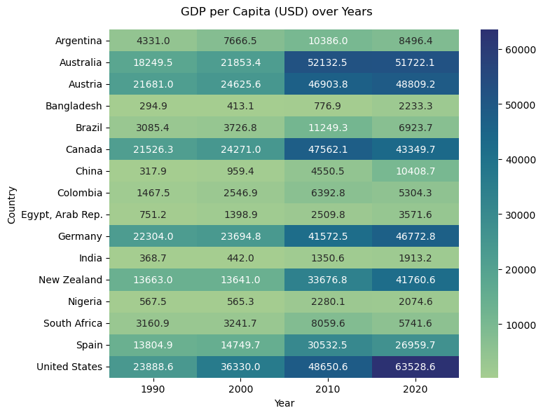

Higher economic prosperity and urban population translates to increased requirements for electricity and other forms of energy consumption. A look into the global kWh per capita values shows aggregate global increase in Energy consumption. With major economic powerhouses like the United States, China and India relying heavily on fossil fuel mediums for energy production, global greenhouse gas emissions are at an all time high.

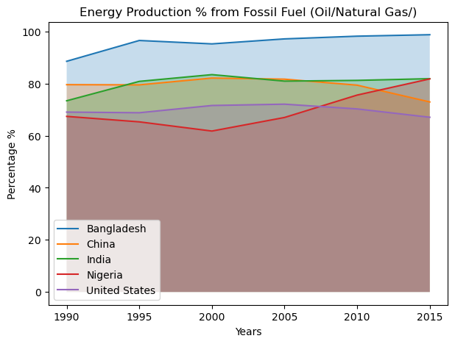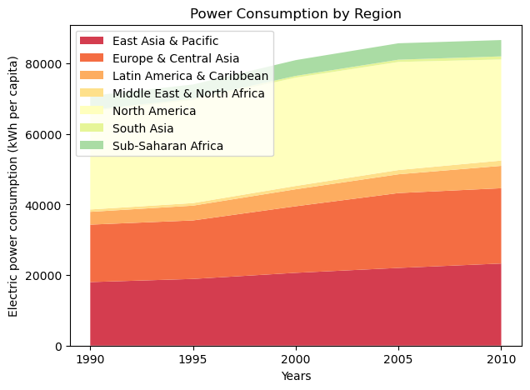

The graphs below show the exponential spike of all greenhouse gases in the atmosphere over a span of 35 years. The bottom right graph shows a slight global decline in total area of land covered by forests in our selected countries. Greenhouse emissions have a strong negative correlation with total forest area. Climate change can be strongly linked to Urbanization and Economic growth on these terms.

